Statistical Methods and Probability
Theory part
Pdf – 1
1. Define Statistics.
Statistics simply means numerical data, and is field of mathematics that generally deals with collection of data, tabulation, and interpretation of numerical data.

2. Important of Statistics.
- Importance of Statistics in Business and Industry
- Importance in the Field of Science and Research
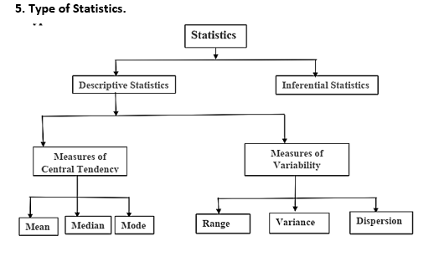
- Importance in the Field of Banking
- Importance in planning

3. Scope of Statistics.
- Presents facts in numerical figures
- Presents complex facts in a simplified form
- Helps in the formulation of policies
- Provides techniques for testing of hypothesis

4. Limitations of Statistics.
- Statistics is Useful for Experts Only
- Statistical Results are not exact
- Statistics Deals with Aggregates Only

Pdf – 2
6. Define Measures of Central Tendency.
A measure of central tendency describes a set of data by identifying the central position in the data set as a single value. Mean, median, and mode are the measures of central tendency.

7. Define Arithmetic Mean with example.
When add up all the values and divide by the number of values it is called Arithmetic Mean.
Example: What is the mean of 3, 5, 9, 5, 7, 2?
Now add up all the given numbers:
3 + 5 + 9 + 5 + 7 + 2 = 31
Now divide by how many numbers are provided in the sequence:
31 / 6 = 5.16

8. Define Geometric Mean with example.
The geometric mean of two numbers x and y is √𝑥𝑦. If you have three numbers x, y, and z, their geometric mean is ³√𝑥𝑦𝑧.
Example: Find the geometric mean of 4 and 3?
𝐺𝑒𝑜𝑚𝑒𝑡𝑟𝑖𝑐 𝑚𝑒𝑎𝑛 = √4 × 3.
= 3.46
9. Define Harmonic Mean with example.
The harmonic mean is used to average ratios. For two numbers x and y, the harmonic mean is 2𝑥𝑦/ (𝑥+𝑦). For, three numbers x, y, and z, the harmonic mean is (𝑥𝑦+3𝑥𝑦𝑧 𝑥𝑧+𝑦𝑧).

10. Define Mean.
The mean is also known as the average, and it is calculated by adding up all the values in a data set and dividing by the total number of values.

Pdf – 3
Set and Operations
1. Universal set:
An universal set is the set of all elements that may possibly be considered in a particular discussion.

𝑈 = {𝑥|𝑥 𝑖𝑠 𝑡𝑜𝑡𝑎𝑙 𝑛𝑢𝑚𝑏𝑒𝑟 𝑜𝑓 𝑠𝑝𝑜𝑡𝑠 𝑢𝑝𝑝𝑒𝑟𝑚𝑜𝑠𝑡 𝑜𝑛 𝑡ℎ𝑒 𝑡𝑤𝑜 𝑑𝑖𝑐𝑒}

2. Venn diagram:
A helpful scheme to illustrate the relationship between sets and set operations.

3. Empty set:
Any set that has no element in it is called an empty, or null set, designated with Ø.

4. Subset:
A set A is a subset of the set B if and only if for each 𝑥 ∈ 𝐴, then 𝑥 ∈ 𝐵.
The set 𝐴 = {1,2,3} is a subset of the set 𝐵 = {1,2,3,4,5,6,7}
5. Proper subset:
𝐴 ⊂ 𝐵
The set 𝐴 = {1,2,3} is a subset of the set 𝐵 = {1,2,3,4,5,6,7} Then 𝐴 ⊂ 𝐵

6. Equal set:
Two sets A and B are said to be equal, or 𝐴 = 𝐵, if and only if 𝐴 ⊆ 𝐵 and 𝐵 ⊆ 𝐴

7. Finite and infinite sets:
A set is called finite if its elements are equal in number to some specifiable nonnegative integers.
A set is called infinite if the number of its elements is greater than any positive integer.

Operation with sets
8. Intersection:
Given the sets A and B, which are subsets of U, the intersection of A and B written as 𝐴 ∩ 𝐵.
𝐴 ∩ 𝐵
If two set have no common element then they are said to be disjoint set.

9. Union:
The union of two sets A and B is the set of all elements belonging to A or B or both. Symbolically denoted by 𝐴 ∪ 𝐵
𝐴 ∪ 𝐵
10. Complementation:
The complement 𝐴̅ of a set A is defined to be a set that contains all outcomes in the universal set U which do not belong to A.
Symbolically,
𝐴̅ = {x|x ∈ U, x ∉ A}
11. Class of sets:
The set 𝐴 = {{𝑎}, {𝑏}, {𝑐}, {𝑑, 𝑒}} is a family or class of sets.

12. Power set:
If 𝐴 = {1,2,3}, then the power set of A is
Ø(𝐴) = {Ø, {1}, {2}, {3}, {1,2}, {1,3}, {2,3}, {1,2,3}}
- 2^{𝑛} elements
13. Cartesian product set:
Let A and B be two sets. The product set of A and B, denoted by 𝐴 × 𝐵, contains all ordered pairs (𝑥, 𝑦), where 𝑥 ∈ 𝐴, 𝑦 ∈ 𝐵.
Example: let 𝐴 = {1,2,3} and 𝐵 = {4,5}. Then the product set of A and B is
𝐴 × 𝐵 = {(1,4), (1,5), (2,4), (2,5), (3,4), (3,5)}

Algebra of Sets

Cumulative laws:
1. 𝐴 ∪ 𝐵 = 𝐵 ∪ 𝐴
2. 𝐴 ∩ 𝐵 = 𝐵 ∩ 𝐴

Math Topic
Pdf – 2
Mean
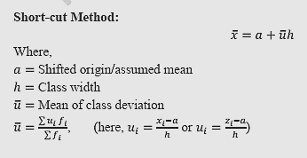
Formula:
1. Mean = Sum of all observations / Number of observations
2. Mean Ungrouped Data = Let, X1, X2, X3, …………..X_{n} be n observations
𝑥 = (𝑥₁+𝑥₂ + ...+ 𝑥_{𝑛}) /𝑛
3. Mean of Grouped data =
𝑥 = (𝑥₁𝑓₁+𝑥₂𝑓₂ + ...+ 𝑥_{𝑛}𝑓_{𝑛}) / (𝑓₁ + 𝑓₂ + ...+ 𝑓_{𝑛})

Practices Math: i. page 3 – Example – ungrouped data
ii. Example 1, 2, 3, 4 (page 3-6) – Grouped data

Pdf – 3
Probability

Math : Sample space এই অংশ টুকু দেখতে পারেন। Page – 4

